Perpendicular Planes

Definition
# Source: AI Source: Provided by: [Data Path: Persons Table -> ID Column: 1, Name_En Column: Motasem Essam] -> From: [ChatGPT] on [7/25/2026]
Perpendicular planes are two planes in three-dimensional space that intersect at a right angle of ${90}^{∘}$.
Their intersection is a straight line, and their normal vectors are perpendicular to each other. Perpendicular planes are a special type of intersecting planes.
For example, the floor and a vertical wall in a room are perpendicular when they meet at a right angle.
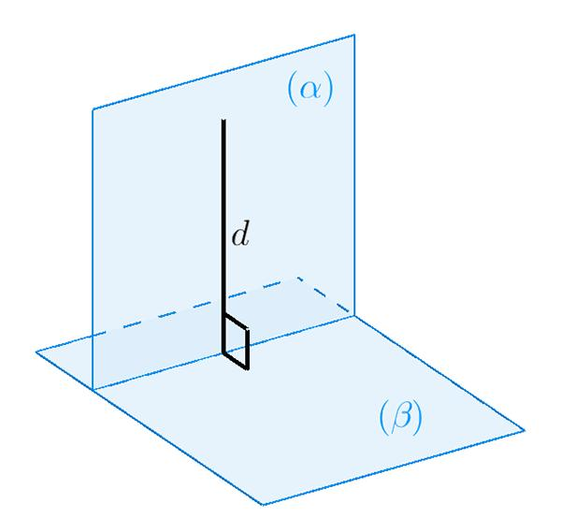
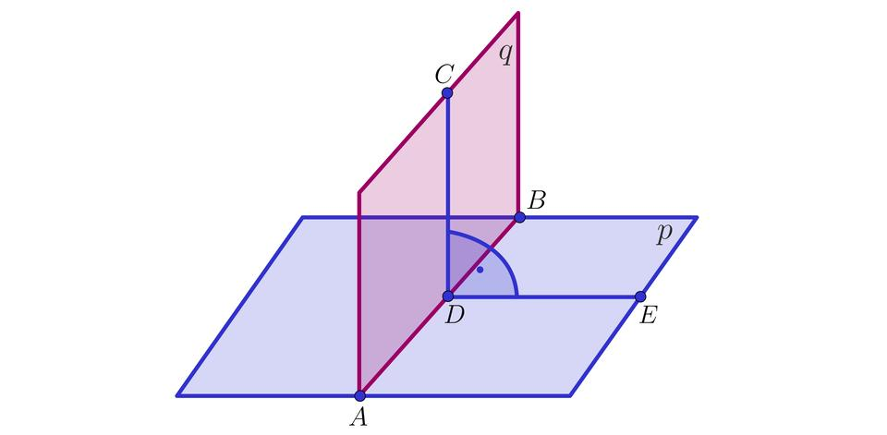
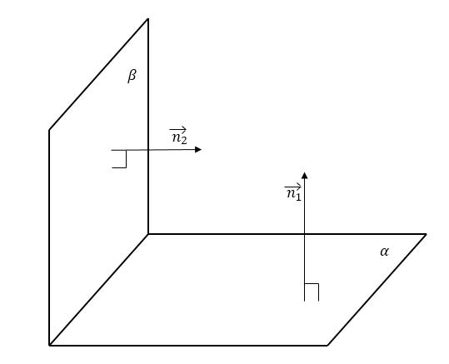

Simple Definition
# Source: AI Source: Provided by: [Data Path: Persons Table -> ID Column: 1, Name_En Column: Motasem Essam] -> From: [ChatGPT] on [7/25/2026]
Two planes are perpendicular when they meet at a right angle.
Examples include:
- A horizontal floor and a vertical wall.
- Two adjacent faces of a cube.
- The $xy$-plane and the $xz$-plane in a three-dimensional coordinate system.
The planes share a common straight line, but their orientations differ by ${90}^{∘}$.

Key Characteristics
# Source: AI Source: Provided by: [Data Path: Persons Table -> ID Column: 1, Name_En Column: Motasem Essam] -> From: [ChatGPT] on [7/25/2026]
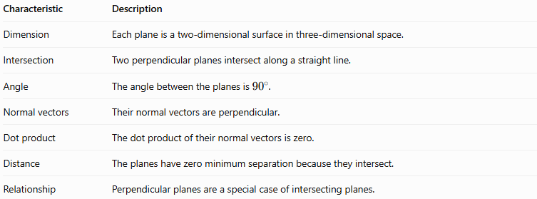
Characteristic | Description
Dimension | Each plane is a two-dimensional surface in three-dimensional space.
Intersection | Two perpendicular planes intersect along a straight line.
Angle | The angle between the planes is ${90}^{∘}$.
Normal vectors | Their normal vectors are perpendicular.
Dot product | The dot product of their normal vectors is zero.
Distance | The planes have zero minimum separation because they intersect.
Relationship | Perpendicular planes are a special case of intersecting planes.

Geometric Representation
# Source: AI Source: Provided by: [Data Path: Persons Table -> ID Column: 1, Name_En Column: Motasem Essam] -> From: [ChatGPT] on [7/25/2026]
The diagram illustrates a horizontal plane $P_{1}$ and a vertical plane $P_{2}$. They intersect along the line $L$ at a right angle.
The planes share the line $L$, and their dihedral angle is ${90}^{∘}$.
The line of intersection separates the two planes into four dihedral angles. When the planes are perpendicular, all four dihedral angles are right angles.

Mathematical Representation

Using normal vectors
# Source: AI Source: Provided by: [Data Path: Persons Table -> ID Column: 1, Name_En Column: Motasem Essam] -> From: [ChatGPT] on [7/25/2026]
A plane can be represented by the equation
$$Ax+By+Cz+D=0$$
Its normal vector is
$$n=\left(A,B,C\right)$$
Suppose two planes have normal vectors
$$n_{1}=\left(A_{1},B_{1},C_{1}\right)$$
$$n_{2}=\left(A_{2},B_{2},C_{2}\right)$$
The planes are perpendicular if and only if their normal vectors have a zero dot product:
$$\boxed{n_{1}⋅n_{2}=0}$$
Expanding this condition gives
$$\boxed{A_{1}A_{2}+B_{1}B_{2}+C_{1}C_{2}=0}$$
This is the main algebraic test for perpendicular planes.

Using the angle between planes
# Source: AI Source: Provided by: [Data Path: Persons Table -> ID Column: 1, Name_En Column: Motasem Essam] -> From: [ChatGPT] on [7/25/2026]
The angle $θ$ between two planes can be calculated from their normal vectors:
$$\cos{θ}=\frac{\left|n_{1}⋅n_{2}\right|}{\left\|n_{1}\right\|\left\|n_{2}\right\|}$$
For perpendicular planes,
$${\cos{90}}^{∘}=0$$
Therefore,
$$n_{1}⋅n_{2}=0$$

Example using coordinate planes
# Source: AI Source: Provided by: [Data Path: Persons Table -> ID Column: 1, Name_En Column: Motasem Essam] -> From: [ChatGPT] on [7/25/2026]
Consider the following coordinate planes:
$$P_{1}:z=0$$
$$P_{2}:y=0$$
The first is the $xy$-plane, with normal vector
$$n_{1}=\left(0,0,1\right)$$
The second is the $xz$-plane, with normal vector
$$n_{2}=\left(0,1,0\right)$$
Their dot product is
$$n_{1}⋅n_{2}=0\left(0\right)+0\left(1\right)+1\left(0\right)=0$$
Thus, the planes are perpendicular. Their line of intersection is the $x$-axis.

Worked Examples
# Source: AI Source: Provided by: [Data Path: Persons Table -> ID Column: 1, Name_En Column: Motasem Essam] -> From: [ChatGPT] on [7/25/2026]
Example 1: Determining whether two planes are perpendicular
Determine whether these planes are perpendicular:
$$P_{1}:2x+y-3z+4=0$$
$$P_{2}:x-5y-z+7=0$$
Step 1: Find the normal vectors.
$$n_{1}=\left(2,1,-3\right)$$
$$n_{2}=\left(1,-5,-1\right)$$
Step 2: Calculate the dot product.
$$\begin{aligned}n_{1}⋅n_{2}&=2\left(1\right)+1\left(-5\right)+\left(-3\right)\left(-1\right) \\ &=2-5+3 \\ &=0\end{aligned}$$
Conclusion: The planes are perpendicular because their normal vectors have a zero dot product.
Example 2: Finding an unknown coefficient
Find $k$ such that the planes
$$P_{1}:2x+3y+z-4=0$$
$$P_{2}:x+ky+2z+5=0$$
are perpendicular.
Their normal vectors are
$$n_{1}=\left(2,3,1\right)$$
$$n_{2}=\left(1,k,2\right)$$
For perpendicular planes, the dot product must equal zero:
$$2\left(1\right)+3k+1\left(2\right)=0$$
$$4+3k=0$$
Therefore,
$$\boxed{k=-\frac{4}{3}}$$
Example 3: Perpendicular faces of a cube
A cube has six square faces. Each pair of adjacent faces is perpendicular.
For a cube aligned with the coordinate axes, consider two adjacent faces:
$$P_{1}:x=0, P_{2}:y=0$$
Their normal vectors are
$$n_{1}=\left(1,0,0\right), n_{2}=\left(0,1,0\right)$$
Since
$$n_{1}⋅n_{2}=0$$
the planes are perpendicular, and their intersection is the $z$-axis.

Comparison with Related Concepts
# Source: AI Source: Provided by: [Data Path: Persons Table -> ID Column: 1, Name_En Column: Motasem Essam] -> From: [ChatGPT] on [7/25/2026]
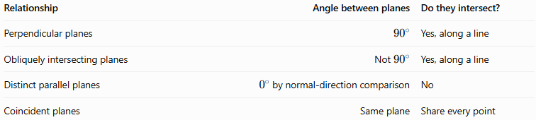
Relationship | Angle between planes | Do they intersect?
Perpendicular planes | $${90}^{∘}$$ | Yes, along a line
Obliquely intersecting planes | Not ${90}^{∘}$ | Yes, along a line
Distinct parallel planes | $0^{∘}$ by normal-direction comparison | No
Coincident planes | Same plane | Share every point
The distinction between perpendicular and obliquely intersecting planes is the angle at which they meet. Both share a line, but only perpendicular planes meet at a right angle.

Applications
# Source: AI Source: Provided by: [Data Path: Persons Table -> ID Column: 1, Name_En Column: Motasem Essam] -> From: [ChatGPT] on [7/25/2026]
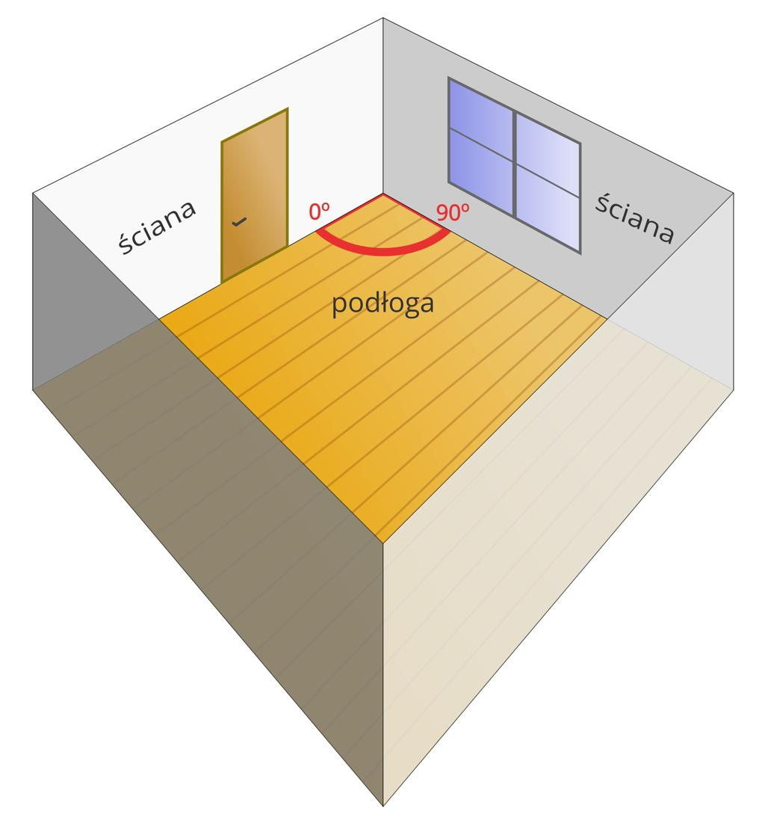
Architecture and construction
Floor-wall junctions and adjacent walls are commonly designed to be perpendicular for square corners and accurate layouts.
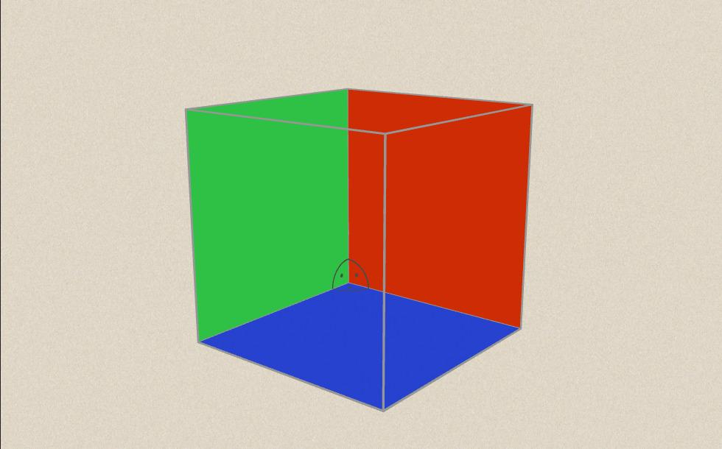
Solid geometry
Cubes and rectangular cuboids provide standard examples for understanding perpendicular faces, edges, and spatial relationships.
Engineering and CAD
The dot-product test helps verify right-angle relationships between modeled surfaces and components.

Key Points
# Source: AI Source: Provided by: [Data Path: Persons Table -> ID Column: 1, Name_En Column: Motasem Essam] -> From: [ChatGPT] on [7/25/2026]
- Perpendicular planes intersect at ${90}^{∘}$.
- They share exactly one straight line when they are distinct.
- Their normal vectors are perpendicular.
- Their normal vectors have a dot product of zero.
- The equation test is
$$A_{1}A_{2}+B_{1}B_{2}+C_{1}C_{2}=0$$
- Adjacent faces of a cube are perpendicular planes.

Conclusion
# Source: AI Source: Provided by: [Data Path: Persons Table -> ID Column: 1, Name_En Column: Motasem Essam] -> From: [ChatGPT] on [7/25/2026]
Perpendicular planes are a special category of intersecting planes whose angle is exactly ${90}^{∘}$. Their relationship can be verified efficiently using normal vectors and the dot product. This concept is important in solid geometry, coordinate geometry, architecture, and three-dimensional modeling.

